CS406 Digital Image Processing
CS/SE, SST, UMT
Assignment 2
Submitted to: Syed Farooq Ali

Name : Luqman Khan
SID : S2024266054
Section : V2
Submitted to: Syed Farooq Ali

Discussion Partner
Name : Muhammad Shahbaz
SID : S202426082

- We haven't discuss one query, but we have discussed all the queries with each other and shared more information with each other.

Question 1
Write a code that takes an input image, keeps only its R-Layer (G and B set to zero) and generates the output image. Apply it on Iambient.ppm, Ileft.ppm and Iright.ppm.

Code

import os

from PIL import Image
import matplotlib.pyplot as plt

images = [r"D:\6th semester\DIP\Iambient.ppm", r"D:\6th semester\DIP\Ileft.ppm", r"D:\6th semester\DIP\Iright.ppm"]

for filename in images:

img = Image.open(filename).convert("RGB")

R, G, B = img.split()

zero = Image.new("L", img.size, 0)

red_image = Image.merge("RGB", (R, zero, zero))

output_name = "R_" + os.path.splitext(filename)[0] + ".png"

# Display output image
plt.figure(figsize=(6, 5))
plt.imshow(red_image)
plt.title("Red Layer: " + filename)
plt.axis("off")
plt.show()

print("Saved:", output_name)

Description of Code
An RGB image is stored as an H x W x 3 matrix: layer 1 is red, layer 2 is green, layer 3 is blue. The code reads each image with imread and creates an all-zero (black) matrix O of the same size and type (uint8). It then copies only layer 1 of the input into layer 1 of O, so G and B stay 0. The result is written with imwrite as <name>_Out.ppm. A for-loop applies the same steps to the three input images.

Result
Every output pixel is (R,0,0), so the images look red only. Bright regions of the original that contain a lot of red (the red desk lamp, the warm table surface, the red magnet toy) stay bright, while objects with little red become dark. Iright and Ileft are brighter than Iambient because the extra lamp adds red light.

Input Images
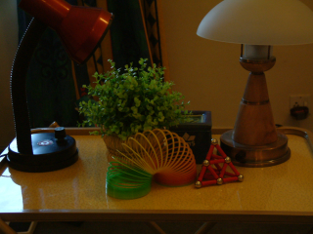  Iambient.ppm | 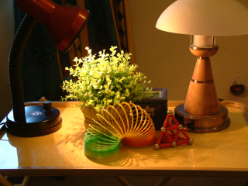  Ileft.ppm | 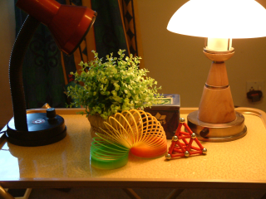  Iright.ppm

Output Image

<Figure size 600x500 with 1 Axes>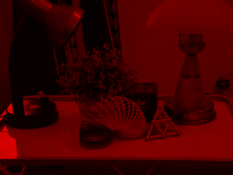  Iambient_Out.ppm | <Figure size 600x500 with 1 Axes>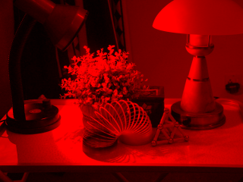  Ileft_Out.ppm | <Figure size 600x500 with 1 Axes>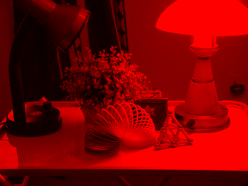  Iright_Out.ppm

Question 2
Keep only the G-Layer (R and B set to zero) and generate the output image.

Code

import os
import matplotlib.pyplot as plt
from PIL import Image

images = [r"D:\6th semester\DIP\Iambient.ppm", r"D:\6th semester\DIP\Ileft.ppm", r"D:\6th semester\DIP\Iright.ppm"]

for filename in images:
img = Image.open(filename).convert("RGB")

R, G, B = img.split()

zero = Image.new("L", img.size, 0)

green_image = Image.merge("RGB", (zero, G, zero))

output_name = "G_" + os.path.splitext(filename)[0] + ".png"

plt.figure(figsize=(6, 5))
plt.imshow(green_image)
plt.title("Green Layer: " + filename)
plt.axis("off")
plt.show()

print("Saved:", output_name)

Description of Code
Same algorithm as Q1, but layer 2 (green) of the input is copied into layer 2 of an all-zero output matrix. R and B remain 0.

Result
Output pixels are (0,G,0), so the images appear in shades of green. The green plant, the green slinky and the lampshade areas are bright; the red lamp and red objects appear dark because they contain little green.

Input Images
Iambient.ppm | Ileft.ppm | Iright.ppm

Output Image
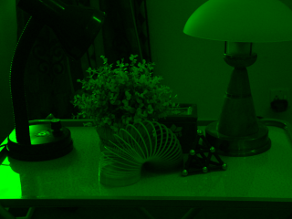  Iambient_Out.ppm | 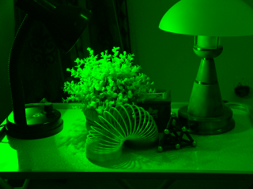  Ileft_Out.ppm | 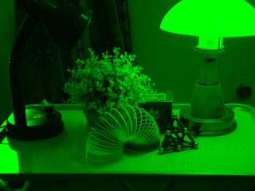  Iright_Out.ppm

Question 3
Keep only the B-Layer (R and G set to zero) and generate the output image.

Code

import os
import matplotlib.pyplot as plt
from PIL import Image

images = [r"D:\6th semester\DIP\Iambient.ppm", r"D:\6th semester\DIP\Ileft.ppm", r"D:\6th semester\DIP\Iright.ppm"]

for filename in images:
img = Image.open(filename).convert("RGB")

R, G, B = img.split()

zero = Image.new("L", img.size, 0)

blue_image = Image.merge("RGB", (zero, zero, B))

output_name = "B_" + os.path.splitext(filename)[0] + ".png"

plt.figure(figsize=(6, 5))
plt.imshow(blue_image)
plt.title("Blue Layer: " + filename)
plt.axis("off")
plt.show()

print("Saved:", output_name)

Description of Code
Same algorithm as Q1, but layer 3 (blue) of the input is copied to the output. R and G are 0.

Result
The output is mostly very dark blue. The scene is lit by warm (yellow/orange) lamps, so there is little blue light. Only the bluish-white lampshade highlight and the blue object on the left show clearly.

Input Images
Iambient.ppm | Ileft.ppm | Iright.ppm

Output Image
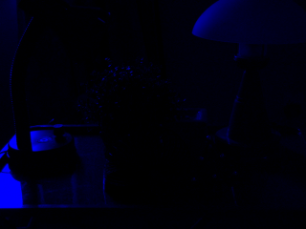Iambient_Out.ppm | 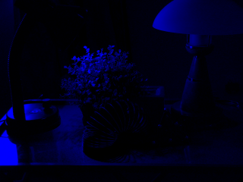  Ileft_Out.ppm | 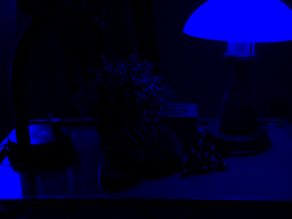  Iright_Out.ppm

Question 4
Keep only the R-Layer and G-Layer (B set to zero) and generate the output image.

Code
import os
import matplotlib.pyplot as plt
from PIL import Image

images = [r"D:\6th semester\DIP\Iambient.ppm", r"D:\6th semester\DIP\Ileft.ppm", r"D:\6th semester\DIP\Iright.ppm"]

for filename in images:
img = Image.open(filename).convert("RGB")

R, G, B = img.split()

zero = Image.new("L", img.size, 0)

output_image = Image.merge("RGB", (R, G, zero))

output_name = "RG_" + os.path.splitext(os.path.basename(filename))[0] + ".png"

output_image.save(output_name)

plt.figure(figsize=(6, 5))
plt.imshow(output_image)
plt.title("Red and Green Layers: " + os.path.basename(filename))
plt.axis("off")
plt.show()

print("Saved:", output_name)

Description of Code
Layers 1 and 2 of the input are copied into the output matrix and layer 3 is left at zero. In additive colour mixing red + green gives yellow.

Result
The images turn yellowish/orange. Because the original scene is already warm, removing blue changes it very little (the blue channel was weak). Bright white areas become yellow.

Input Images
Iambient.ppm | Ileft.ppm | Iright.ppm

Output Image
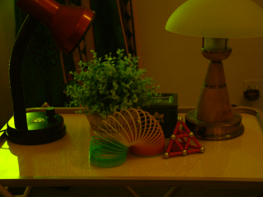  Iambient_Out.ppm | 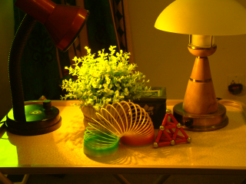  Ileft_Out.ppm | 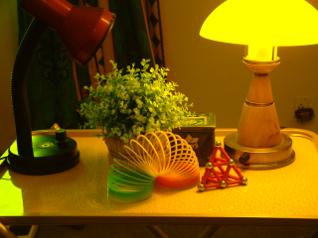  Iright_Out.ppm

Question 5
Keep only the R-Layer and B-Layer (G set to zero) and generate the output image.

Code
import os
import matplotlib.pyplot as plt
from PIL import Image

images = [r"D:\6th semester\DIP\Iambient.ppm", r"D:\6th semester\DIP\Ileft.ppm", r"D:\6th semester\DIP\Iright.ppm"]

for filename in images:
img = Image.open(filename).convert("RGB")

R, G, B = img.split()

zero = Image.new("L", img.size, 0)

output_image = Image.merge("RGB", (R, zero, B))

output_name = "RB_" + os.path.splitext(os.path.basename(filename))[0] + ".png"

output_image.save(output_name)

plt.figure(figsize=(6, 5))
plt.imshow(output_image)
plt.title("Red and Blue Layers: " + os.path.basename(filename))
plt.axis("off")
plt.show()

print("Saved:", output_name)

Description of Code
Layers 1 and 3 are copied and layer 2 (green) is set to zero. Red + blue gives magenta.

Result
The images get a magenta/purple tint. Green objects (plant, green slinky) become dark, and white areas become magenta because green is removed.

Input Images
Iambient.ppm | Ileft.ppm | Iright.ppm

Output Image
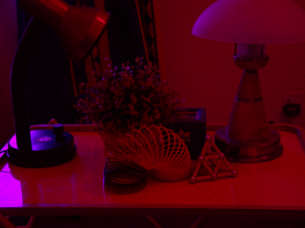  Iambient_Out.ppm | 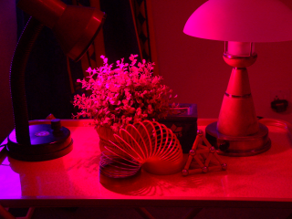  Ileft_Out.ppm | 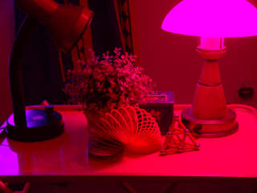  Iright_Out.ppm

Question 6
Keep only the G-Layer and B-Layer (R set to zero) and generate the output image.

Code
import os
import matplotlib.pyplot as plt
from PIL import Image

images = [r"D:\6th semester\DIP\Iambient.ppm", r"D:\6th semester\DIP\Ileft.ppm", r"D:\6th semester\DIP\Iright.ppm"]

for filename in images:
img = Image.open(filename).convert("RGB")

R, G, B = img.split()

zero = Image.new("L", img.size, 0)

output_image = Image.merge("RGB", (zero, G, B))

output_name = "GB_" + os.path.splitext(os.path.basename(filename))[0] + ".png"

output_image.save(output_name)

plt.figure(figsize=(6, 5))
plt.imshow(output_image)
plt.title("Green and Blue Layers: " + os.path.basename(filename))
plt.axis("off")
plt.show()

print("Saved:", output_name)

Description of Code
Layers 2 and 3 are copied and layer 1 (red) is set to zero. Green + blue gives cyan.

Result
The images get a cyan/teal tint. Red and orange objects (red lamp, red magnets, warm table) become dark, and white areas turn cyan.

Input Images
Iambient.ppm | Ileft.ppm | Iright.ppm

Output Image
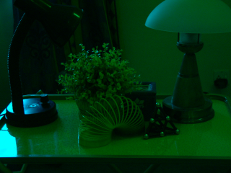  Iambient_Out.ppm | 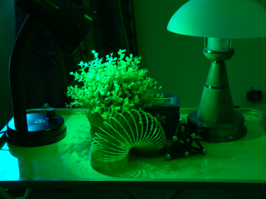  Ileft_Out.ppm | 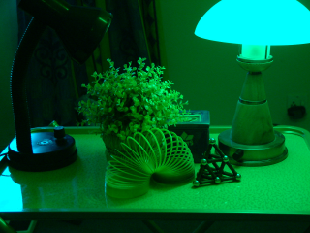  Iright_Out.ppm

Question 7
Write a code that takes the inverse of the input image (255 - Input Image).

Code
import os
import matplotlib.pyplot as plt
from PIL import Image, ImageChops

images = [r"D:\6th semester\DIP\Iambient.ppm", r"D:\6th semester\DIP\Ileft.ppm", r"D:\6th semester\DIP\Iright.ppm"]

for filename in images:
img = Image.open(filename).convert("RGB")

inverse_image = ImageChops.invert(img)

output_name = "Inverse_" + os.path.splitext(os.path.basename(filename))[0] + ".png"

inverse_image.save(output_name)

plt.figure(figsize=(6, 5))
plt.imshow(inverse_image)
plt.title("Inverse Image: " + os.path.basename(filename))
plt.axis("off")
plt.show()

print("Saved:", output_name)

Description of Code
Each pixel value in every layer is subtracted from 255. Because the image is uint8, 255 - I stays within 0..255 and no clipping is needed. Dark pixels become bright and bright pixels become dark, and colours become their complements (red becomes cyan, yellow becomes blue).

Result
The outputs are photographic negatives: the dark background becomes very bright, the bright lampshade becomes dark, and the warm orange tones become bluish.

Input Images
Iambient.ppm | Ileft.ppm | Iright.ppm

Output Image
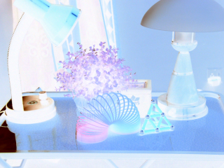  Iambient_Out.ppm | 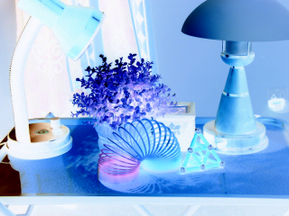  Ileft_Out.ppm | 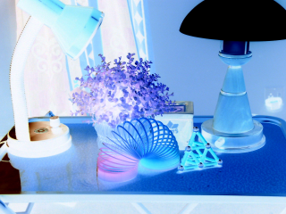  Iright_Out.ppm

Question 8
Convert the input image into gray scale using Gray = 0.3R + 0.59G + 0.11B.

Code
import os
import numpy as np
import matplotlib.pyplot as plt
from PIL import Image

images = [r"D:\6th semester\DIP\Iambient.ppm", r"D:\6th semester\DIP\Ileft.ppm", r"D:\6th semester\DIP\Iright.ppm"]

for filename in images:
img = Image.open(filename).convert("RGB")

R, G, B = img.split()

R = np.array(R, dtype=float)
G = np.array(G, dtype=float)
B = np.array(B, dtype=float)

gray_array = (0.3 * R + 0.59 * G + 0.11 * B).astype(np.uint8)

gray_image = Image.fromarray(gray_array)

output_name = "Gray_" + os.path.splitext(os.path.basename(filename))[0] + ".png"

gray_image.save(output_name)

plt.figure(figsize=(6, 5))
plt.imshow(gray_image, cmap="gray")
plt.title("Grayscale Image: " + os.path.basename(filename))
plt.axis("off")
plt.show()

print("Saved:", output_name)

Description of Code
The image is converted to double so the weighted sum is not rounded or saturated early. A single 2D matrix G = 0.3*R + 0.59*G + 0.11*B is computed (green gets the largest weight because the eye is most sensitive to it), then converted back to uint8. Since a PPM file needs 3 layers, G is copied into all three layers so R = G = B.

Result
The outputs have no colour, only brightness levels. Brightness relationships are preserved: the lampshade and highlights are white, the dark lamp base is almost black.

Input Images
Iambient.ppm | Ileft.ppm | Iright.ppm

Output Image
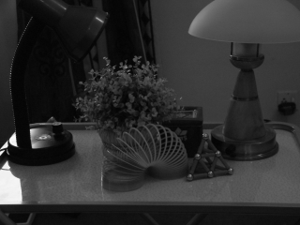  Iambient_Out.ppm | 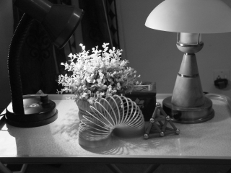  Ileft_Out.ppm | 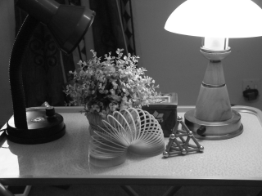  Iright_Out.ppm

Question 9
Generate LeftContribution.ppm by subtracting Iambient.ppm from Ileft.ppm.

Code
import matplotlib.pyplot as plt
from PIL import Image, ImageChops

left = Image.open(r"D:\6th semester\DIP\Ileft.ppm").convert("RGB")
ambient = Image.open(r"D:\6th semester\DIP\Iambient.ppm").convert("RGB")

left_contribution = ImageChops.subtract(left, ambient)

left_contribution.save("LeftContribution.ppm")

plt.figure(figsize=(6, 5))
plt.imshow(left_contribution)
plt.title("Left Contribution")
plt.axis("off")
plt.show()

print("Saved: LeftContribution.ppm")

Description of Code
Ileft contains ambient light plus the left lamp. Subtracting Iambient removes the ambient part, leaving only the light added by the left lamp. imread returns uint8 images, and uint8 subtraction in MATLAB saturates at 0, so any negative value (noise) becomes 0 instead of wrapping around to a large number.

Result
The output shows the scene as if lit only by the left lamp: the plant and the left side are bright, while the right lamp and its shade are dark.

Input Images
Ileft.ppm | Iambient.ppm

Output Image
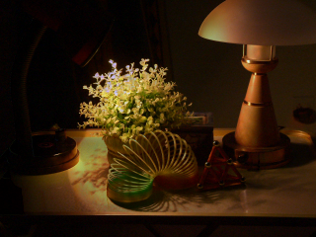
LeftContribution.ppm

Question 10
Generate RightContribution.ppm by subtracting Iambient.ppm from Iright.ppm.

Code
import matplotlib.pyplot as plt
from PIL import Image, ImageChops

right = Image.open(r"D:\6th semester\DIP\Iright.ppm").convert("RGB")
ambient = Image.open(r"D:\6th semester\DIP\Iambient.ppm").convert("RGB")

right_contribution = ImageChops.subtract(right, ambient)

right_contribution.save("RightContribution.ppm")

plt.figure(figsize=(6, 5))
plt.imshow(right_contribution)
plt.title("Right Contribution")
plt.axis("off")
plt.show()

print("Saved: RightContribution.ppm")

Description of Code
Same method as Q9 using Iright. The ambient light is removed so only the right lamp contribution remains. Negative values saturate to 0.

Result
The scene appears lit only by the right lamp: the right lampshade is very bright and the objects near it are lit, while the left part is darker.

Input Images
Iright.ppm | Iambient.ppm

Output Image
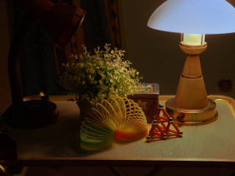
RightContribution.ppm

Question 11
Generate redLeftGreenRightContribution.ppm: first make LeftContribution and RightContribution (Q9, Q10), then add the red layer of LeftContribution to the green layer of RightContribution.

Code
import matplotlib.pyplot as plt
from PIL import Image

left = Image.open("LeftContribution.ppm").convert("RGB")
right = Image.open("RightContribution.ppm").convert("RGB")

R_left, G_left, B_left = left.split()
R_right, G_right, B_right = right.split()

zero = Image.new("L", left.size, 0)

output_image = Image.merge("RGB", (R_left, G_right, zero))

output_image.save("redLeftGreenRightContribution.ppm")

plt.figure(figsize=(6, 5))
plt.imshow(output_image)
plt.title("Red Left Green Right Contribution")
plt.axis("off")
plt.show()

print("Saved: redLeftGreenRightContribution.ppm")

Description of Code
Step 1 recomputes LeftContribution and RightContribution. Step 2 builds RedLeft (only layer 1 of LeftContribution, others 0) and GreenRight (only layer 2 of RightContribution, others 0). The two images use different layers, so adding them does not overflow: the result has R from the left lamp and G from the right lamp, B = 0.

Result
The left lamp now lights the scene in red and the right lamp lights it in green. Regions lit by both lamps appear yellow, which is a coloured-lights effect made possible by capturing each lamp separately.

Input Images
LeftContribution.ppm | RightContribution.ppm

Output Image
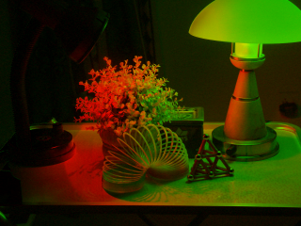
redLeftGreenRightContribution.ppm

Question 12
Morphing: generate a sequence of images using I_t = w*Ia + (1-w)*Ib, with Ia = Iright, Ib = Ileft and w varied from 0 to 1 at equal intervals.

Code
import os
import matplotlib.pyplot as plt
from PIL import Image

right = Image.open(r"D:\6th semester\DIP\Iright.ppm").convert("RGB")
left = Image.open(r"D:\6th semester\DIP\Ileft.ppm").convert("RGB")

if right.size != left.size:
raise ValueError("Both images must have the same dimensions.")

os.makedirs("Morphing_Images", exist_ok=True)

for i in range(11):
w = i / 10

output_image = Image.blend(left, right, w)

output_name = f"Morphing_Images/Morph_{i:02d}.ppm"

output_image.save(output_name)

plt.figure(figsize=(6, 5))
plt.imshow(output_image)
plt.title(f"Image Morphing: w = {w:.1f}")
plt.axis("off")
plt.show()

print("Saved:", output_name)

Description of Code
Both images are converted to double so that the weighted average does not lose precision. A loop varies w from 0 to 1 in steps of 0.1 (11 frames, including both end images). For each w the code computes w*Ia + (1-w)*Ib, converts the result back to uint8 and writes it as Morph_w<w>.ppm. The frames can be joined into a movie (the code also writes morph.avi with VideoWriter).

Result
At w = 0 the output is exactly Ileft (left lamp on) and at w = 1 it is exactly Iright (right lamp on). Intermediate frames blend the two: the left lamp gradually dims and the right lamp gradually brightens, giving a smooth lighting transition. This is a cross-dissolve of lighting, not a geometric morph, because the camera did not move.

Input Images
Ia = Iright.ppm | Ib = Ileft.ppm

Output Image
w = 0.0 | 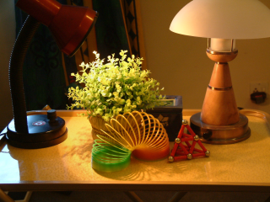  w = 0.1 |  | 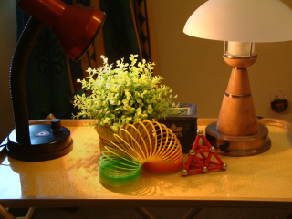  w = 0.2 |  | 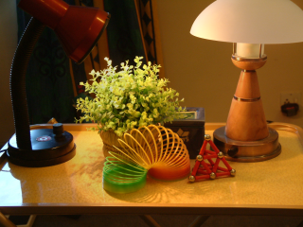  w = 0.3
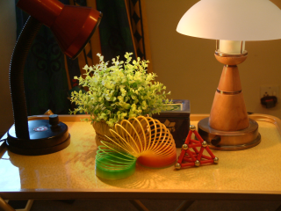  w = 0.4 | 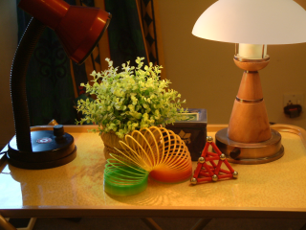  w = 0.5 |  | 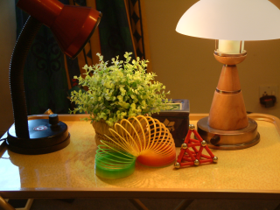  w = 0.6 |  | 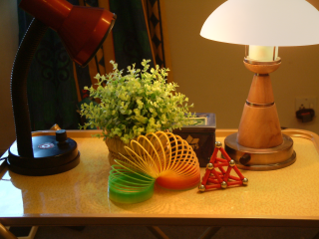  w = 0.7
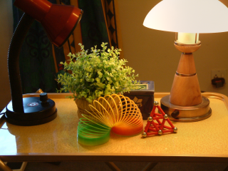  w = 0.8 |  | 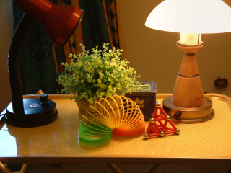  w = 0.9 |  | w = 1.0
Files: Output_Q12/Morph_00_w0.0.ppm ... Morph_10_w1.0.ppm and the movie Morph_Movie.avi (gif/mp4 copies included).

